Mpower Communications Corp. Original P.U.C. Schedule F-1
d/b/a TelePacific Communications Original Sheet A
515 Flower Street, 47th Floor
Los Angeles, CA 90071
SAMPLE FORMS

CHECK SHEET

This tariff contains the following sheets, each of which is effective on the date shown at the bottom of each sheet. The sheets named below are currently in effect as of the date on the bottom of this sheet.

Sheet No. Revision
A Original
B Original

Section 1
1-1 Original
  - Original
1-3 Original
1-4 Original
1-5 Original
  - Original
  - Original

Advice Letter No. 378 Issued By Date Filed: September 1, 2006
Nancy Lubamersky Effective: October 1, 2006

Decision No. VP – Public Policy Resolution No. ___________
Mpower Communications Corp. Original P.U.C. Schedule F-1
d/b/a TelePacific Communications Original Sheet B
515 Flower Street, 47th Floor
Los Angeles, CA 90071
SAMPLE FORMS

TABLE OF CONTENTS

Page No.

Check Sheet A

Table of Contents B

1. SAMPLE FORMS 1-1
1.1 Standard Service Order 1-1
1.2 Service Order Addendum 1-2
1.3 Terms and Conditions 1-3
1.4 Late Notice 1-5
1.5 Customer Bill 1-6
1.6 Automatic Payment Authorization Form 1-7

Advice Letter No. 378 Issued By Date Filed: September 1, 2006
Nancy Lubamersky Effective: October 1, 2006

Decision No. VP – Public Policy Resolution No. ___________
Mpower Communications Corp. Original P.U.C. Schedule F-1
d/b/a TelePacific Communications Original Sheet No. 1-1 T
515 Flower Street, 47th Floor
Los Angeles, CA 90071
SAMPLE FORMS

1. SAMPLE FORMS
1.1 Standard Service Order
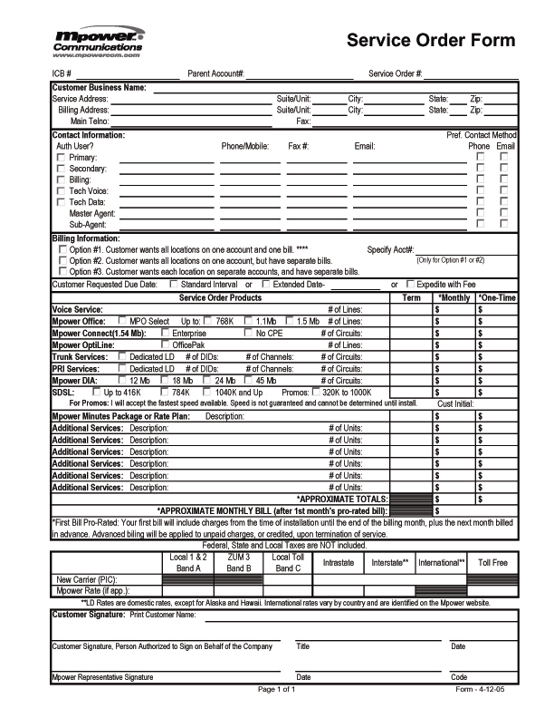

Advice Letter No. 378 Issued By Date Filed: September 1, 2006
Nancy Lubamersky Effective: October 1, 2006

Decision No. VP – Public Policy Resolution No. ___________
Mpower Communications Corp. Original P.U.C. Schedule F-1
d/b/a TelePacific Communications Original Sheet No. 1-2 T
515 Flower Street, 47th Floor
Los Angeles, CA 90071
SAMPLE FORMS

1. SAMPLE FORMS (CONT’D)
1.2 Service Order Addendum

ADDENDUM TO CUSTOMER AGREEMENT

WHEREAS Mpower Communications Corp. (“Mpower”) and (“Customer”), (collectively “the Parties”) have entered into a Customer Agreement (“Agreement”) numbered ______________ which permits the Parties to mutually add to or change the Agreement in writing;

WHEREAS Mpower desires of provide Customer with special rate(s) in exchange for Customer agreeing to satisfy certain conditions as the basis for obtaining said rate(s); and

NOW THEREFORE, the Parties agree as follows:

1. Addendum Start Date. The start date of this Addendum shall be the start date for Prorated Charges specified on Customer’s initial invoice for the Services specified below.

2. Addendum Term. The term of this Addendum shall be 2 years.

3. Services.

4. Conditions and Related Rates.

Customer shall receive the following special rate(s) for Services identified in paragraph 3 above if Customer agrees to purchase the following package of:

If Customer fails to satisfy the minimum requirements specified above, Customer shall be billed at the standard rates specified in Mpower’s tariffs for the Services specified above.

- All of the other provisions of the Agreement shall remain in full force and effect.

- Confidentiality: Customer requests that its identity be kept confidential and not publicly disclosed by Mpower or the Commission, unless required by law.

- Governing Law: This Agreement shall at all times be governed by the laws of the State of California excluding its choice of law rules, and by the regulations of the Commission.

IN WITNESS WHEREOF, the Parties hereto have caused this Amendment to be executed by their respective duly authorized representatives on the date indicated below.

Mpower Communications Corp
______________________________
Name Name
________________________________ ______________________________
Signature Signature
______________________________
Title Title
______________________________
Date Date

Advice Letter No. 378 Issued By Date Filed: September 1, 2006
Nancy Lubamersky Effective: October 1, 2006

Decision No. VP – Public Policy Resolution No. ___________
Mpower Communications Corp. Original P.U.C. Schedule F-1
d/b/a TelePacific Communications Original Sheet No. 1-3 T
515 Flower Street, 47th Floor
Los Angeles, CA 90071
SAMPLE FORMS

1. SAMPLE FORMS (CONT’D)
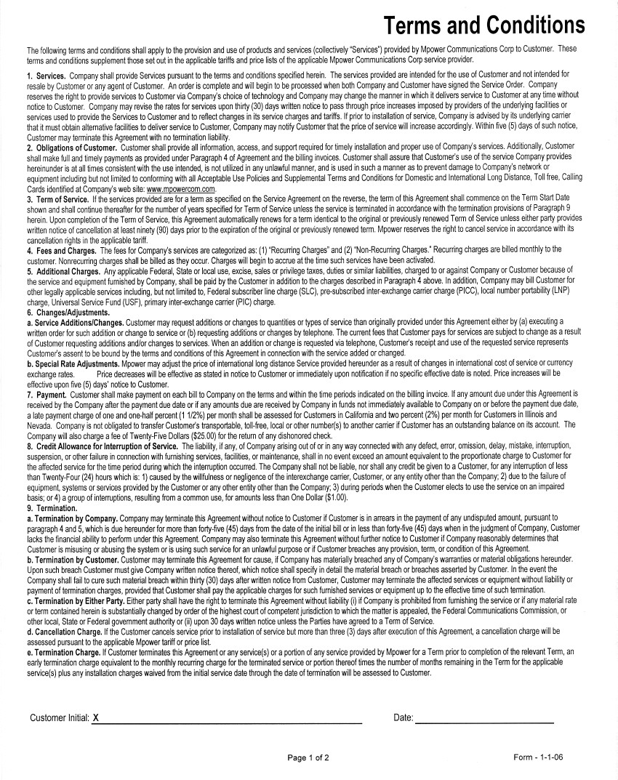
1.3 Terms and Conditions

Advice Letter No. 378 Issued By Date Filed: September 1, 2006
Nancy Lubamersky Effective: October 1, 2006

Decision No. VP – Public Policy Resolution No. ___________
Mpower Communications Corp. Original P.U.C. Schedule F-1
d/b/a TelePacific Communications Original Sheet No. 1-4 T
515 Flower Street, 47th Floor
Los Angeles, CA 90071
SAMPLE FORMS

1. SAMPLE FORMS (CONT’D)
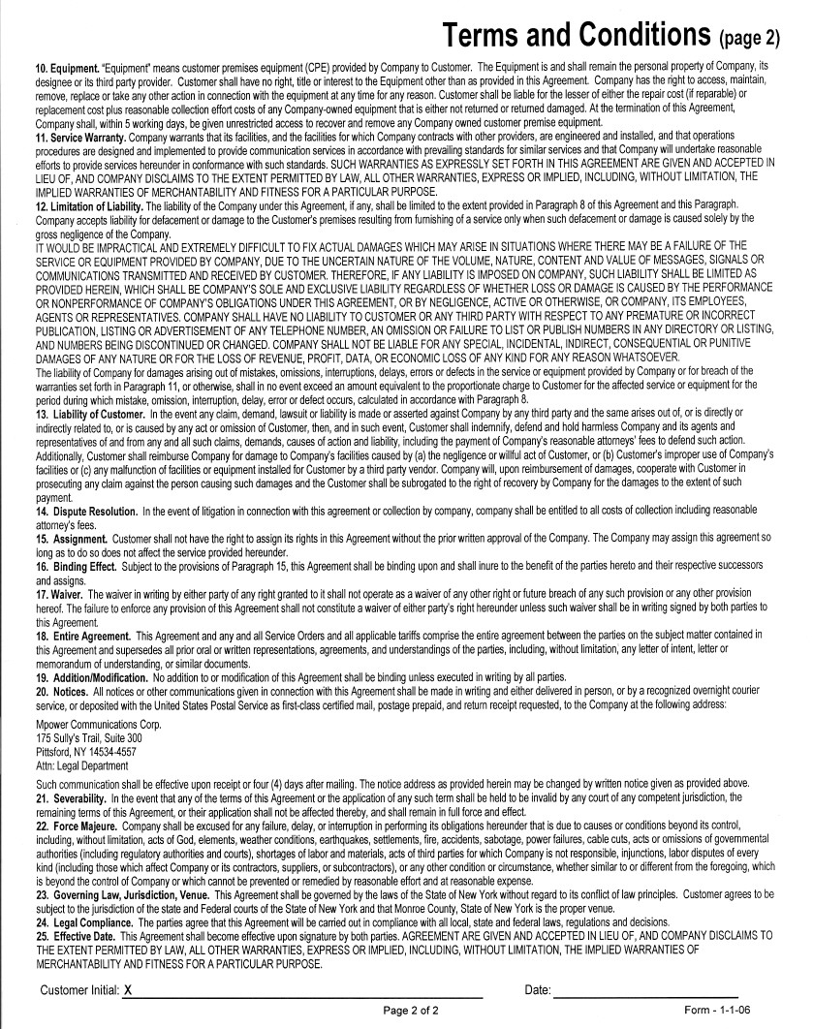
1.3 Terms and Conditions (Cont’d)

Advice Letter No. 378 Issued By Date Filed: September 1, 2006
Nancy Lubamersky Effective: October 1, 2006

Decision No. VP – Public Policy Resolution No. ___________
Mpower Communications Corp. Original P.U.C. Schedule F-1
d/b/a TelePacific Communications Original Sheet No. 1-5 T
515 Flower Street, 47th Floor
Los Angeles, CA 90071
SAMPLE FORMS

1. SAMPLE FORMS (CONT’D)
  - Late Notice
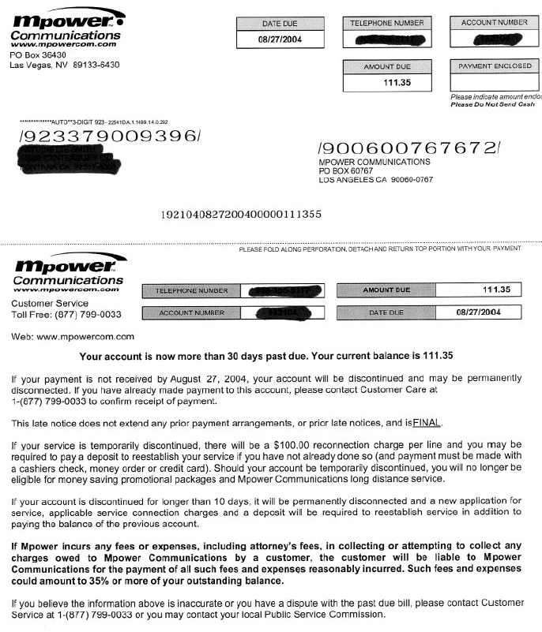

Advice Letter No. 378 Issued By Date Filed: September 1, 2006
Nancy Lubamersky Effective: October 1, 2006

Decision No. VP – Public Policy Resolution No. ___________
Mpower Communications Corp. Original P.U.C. Schedule F-1
d/b/a TelePacific Communications Original Sheet No. 1-6 T
515 Flower Street, 47th Floor
Los Angeles, CA 90071
SAMPLE FORMS

1. SAMPLE FORMS (CONT’D)
1.5. Customer Bill
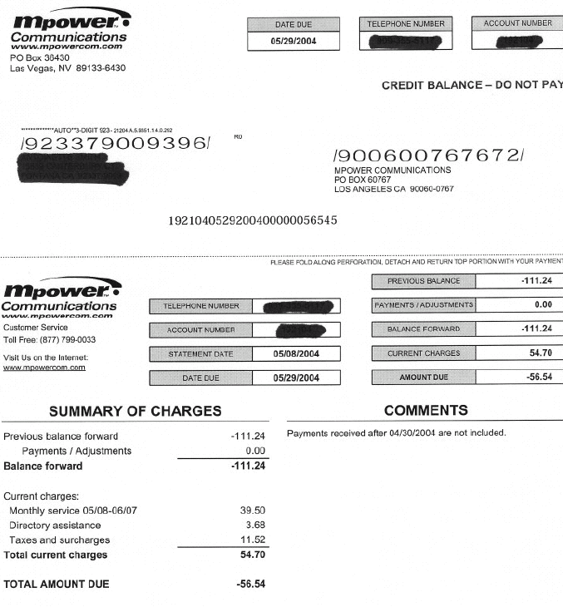

Advice Letter No. 378 Issued By Date Filed: September 1, 2006
Nancy Lubamersky Effective: October 1, 2006

Decision No. VP – Public Policy Resolution No. ___________
Mpower Communications Corp. Original P.U.C. Schedule F-1
d/b/a TelePacific Communications Original Sheet No. 1-7 T
515 Flower Street, 47th Floor
Los Angeles, CA 90071
SAMPLE FORMS

1. SAMPLE FORMS (CONT’D)
1.6. Automatic Payment Authorization Form
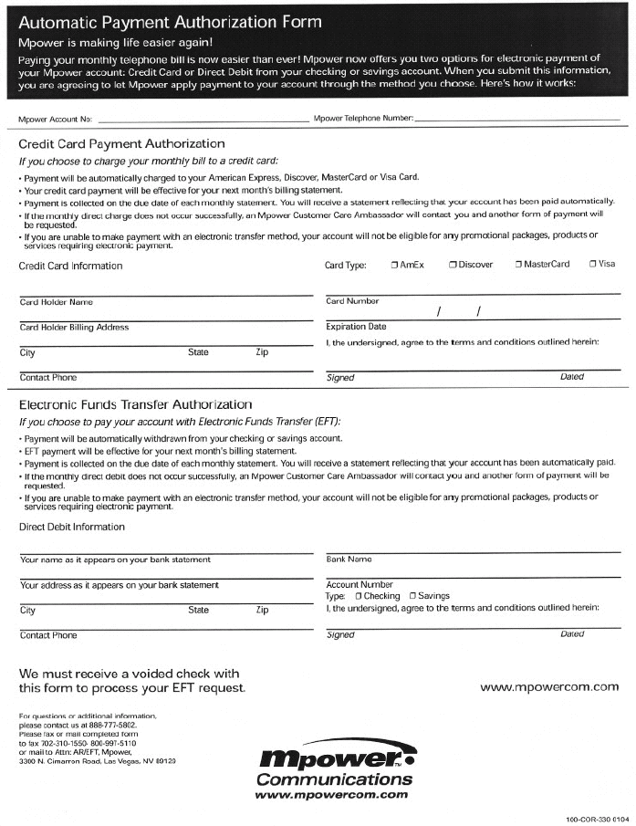

Advice Letter No. 378 Issued By Date Filed: September 1, 2006
Nancy Lubamersky Effective: October 1, 2006

Decision No. VP – Public Policy Resolution No. ___________

